

UNIVERSITY OF SYDNEY

**INFO2222**

Usability and Security

**LOGBOOK**

**of**

**Project Brief**

SID: 490441372

March 12th, 2021

**PERSONAs**

The sample persona based on our **team’s** thoughts.

|  |  |
| --- | --- |
| **Attribute** | **Value** |
| Name | Jasmine Valdez (she/her) |
| Age | 20 (Second Year) |
| Gender | Female |
| Background | Grew up in the Blue Mountains |
| Reason for choosing USYD | * Likes the degree structure and offerings (Advanced Computing) |
| Likes about USYD | * Campus |
| Dislikes about USYD | * Poorly / administered managed units |
| Opinions on USYD systems | * Edstem   + Likes messaging and forum system   + Likes design   + Dislikes notification structure * Canvas   + Dislikes its calendar system   + Dislikes reminder system   + Likes info of courses   + Likes layout of navigation and menus * Sydney Student: Mucky, hate it * Dislikes email notification systems |
| Program of study | Advanced Computing (Computer Science, Finance) |
| Favourite unit of study | INFO1113 |
| Personal challenges | Shy / lack of confidence |
| Career goal | Mega Tech company / investment corporation |
| Plans after graduation | Full-time work |

**PACT analysis of project space (collaborate with team)**

*People use technologies to undertake activities in contexts*

People

* Students from The University of Sydney
* Website admin(s)

Technologies

* Access to the Internet
* Input the keyword about the part of web development what they want
* View the tutorial material about what they want to learn
* Material came from the web-development-related courses from University

Activities

* Learn the basic skill of website development
* Discuss and solve problems with other developers

Contexts

* Related to web development skills and knowledge

**GROUP MEETING NOTES**

First of all, we introduced ourselves at the beginning in order to form a group better.

Then we wrote our checklist according to project brief. What we need to do this week is Task1 and Task2 in project brief, so we analyze this.

1. We need to find the needs and characteristics of our users.

2. We need consider what functions can our website provide to users.

3. We also drafted the team contract and everyone signed it.

Finally we planned what we needed to do at the next meeting.

**Source codes: routing to different pages**

from bottle import template, run, route

@route('/')

@route('/hello/<name>')

def greet(name = 'Stranger'):

return template('Hello {{name}}, <b>how are you?<b>', name = name)

run(host = 'localhost', port = 8080, debug = True)

**Source codes to create SYNCs 'About Us' page**

from bottle import static_file, run, route

@route('/assets/<filename:path>')

def send_static(filename):

print(filename)

return static_file(filename, root='./SUITS/assets/')

@route('/assets_sync/<filename:path>')

def send_static(filename):

print(filename)

return static_file(filename, root='./SYNCS/assets/')

@route('/')

@route('/module1/syncs')

def syncs():

return static_file("About Us - SYNCS.html", root = './SYNCS/')

@route('/module1/suits')

def suits():

return static_file("About Us - SUITS.html", root = './SUITS/')

run(host = 'localhost', port = 8080, debug = True)

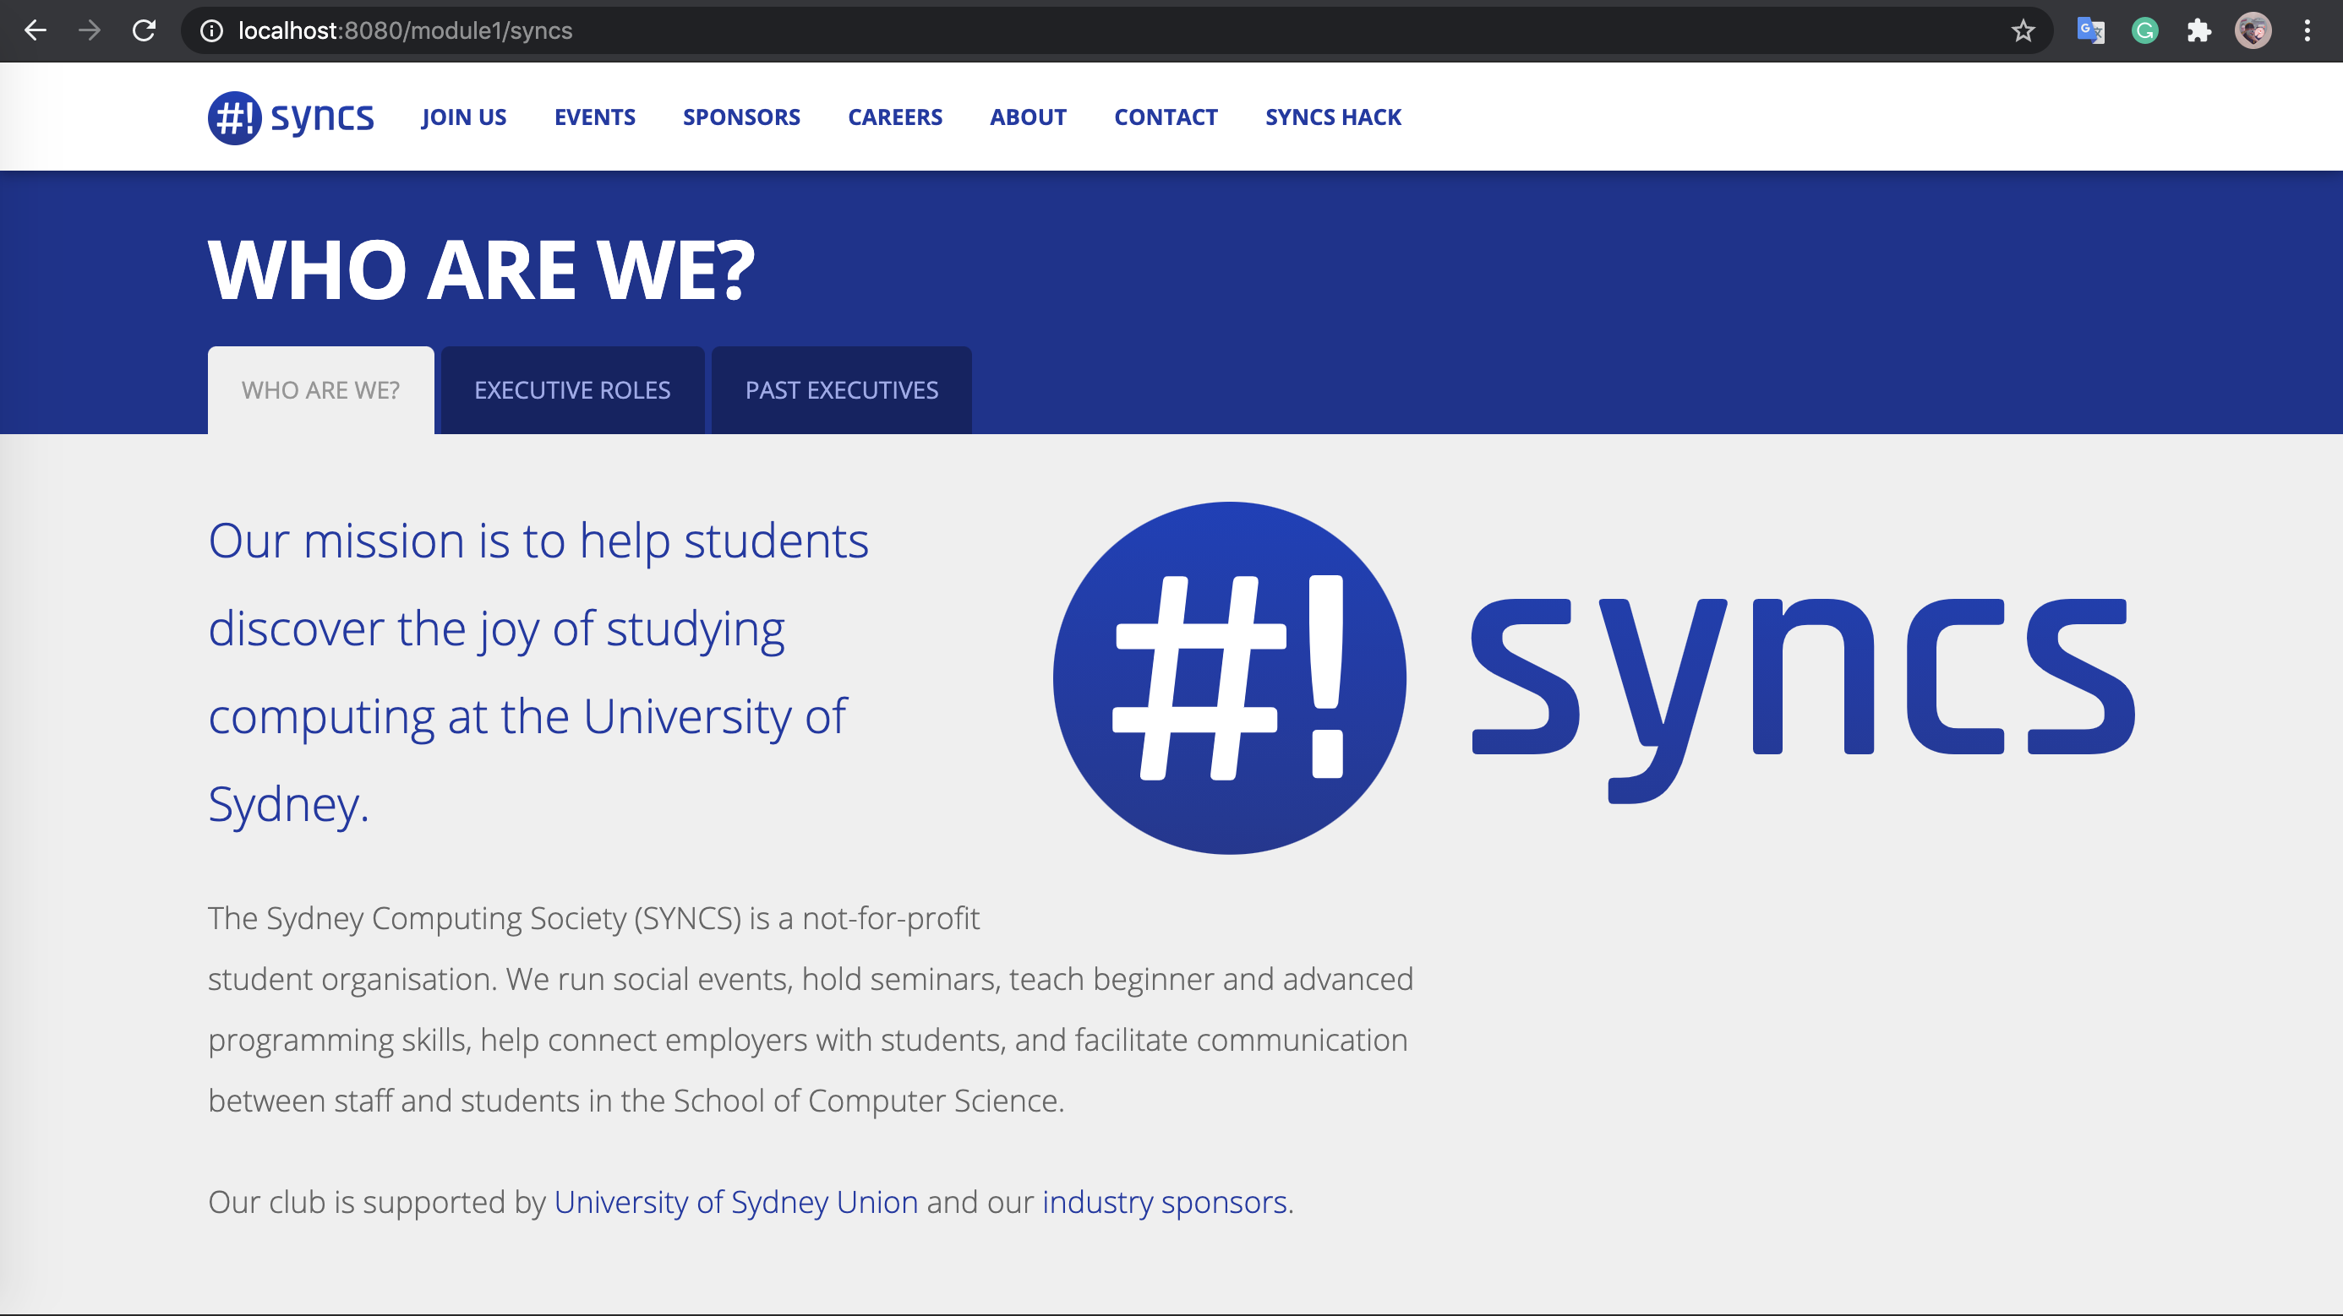

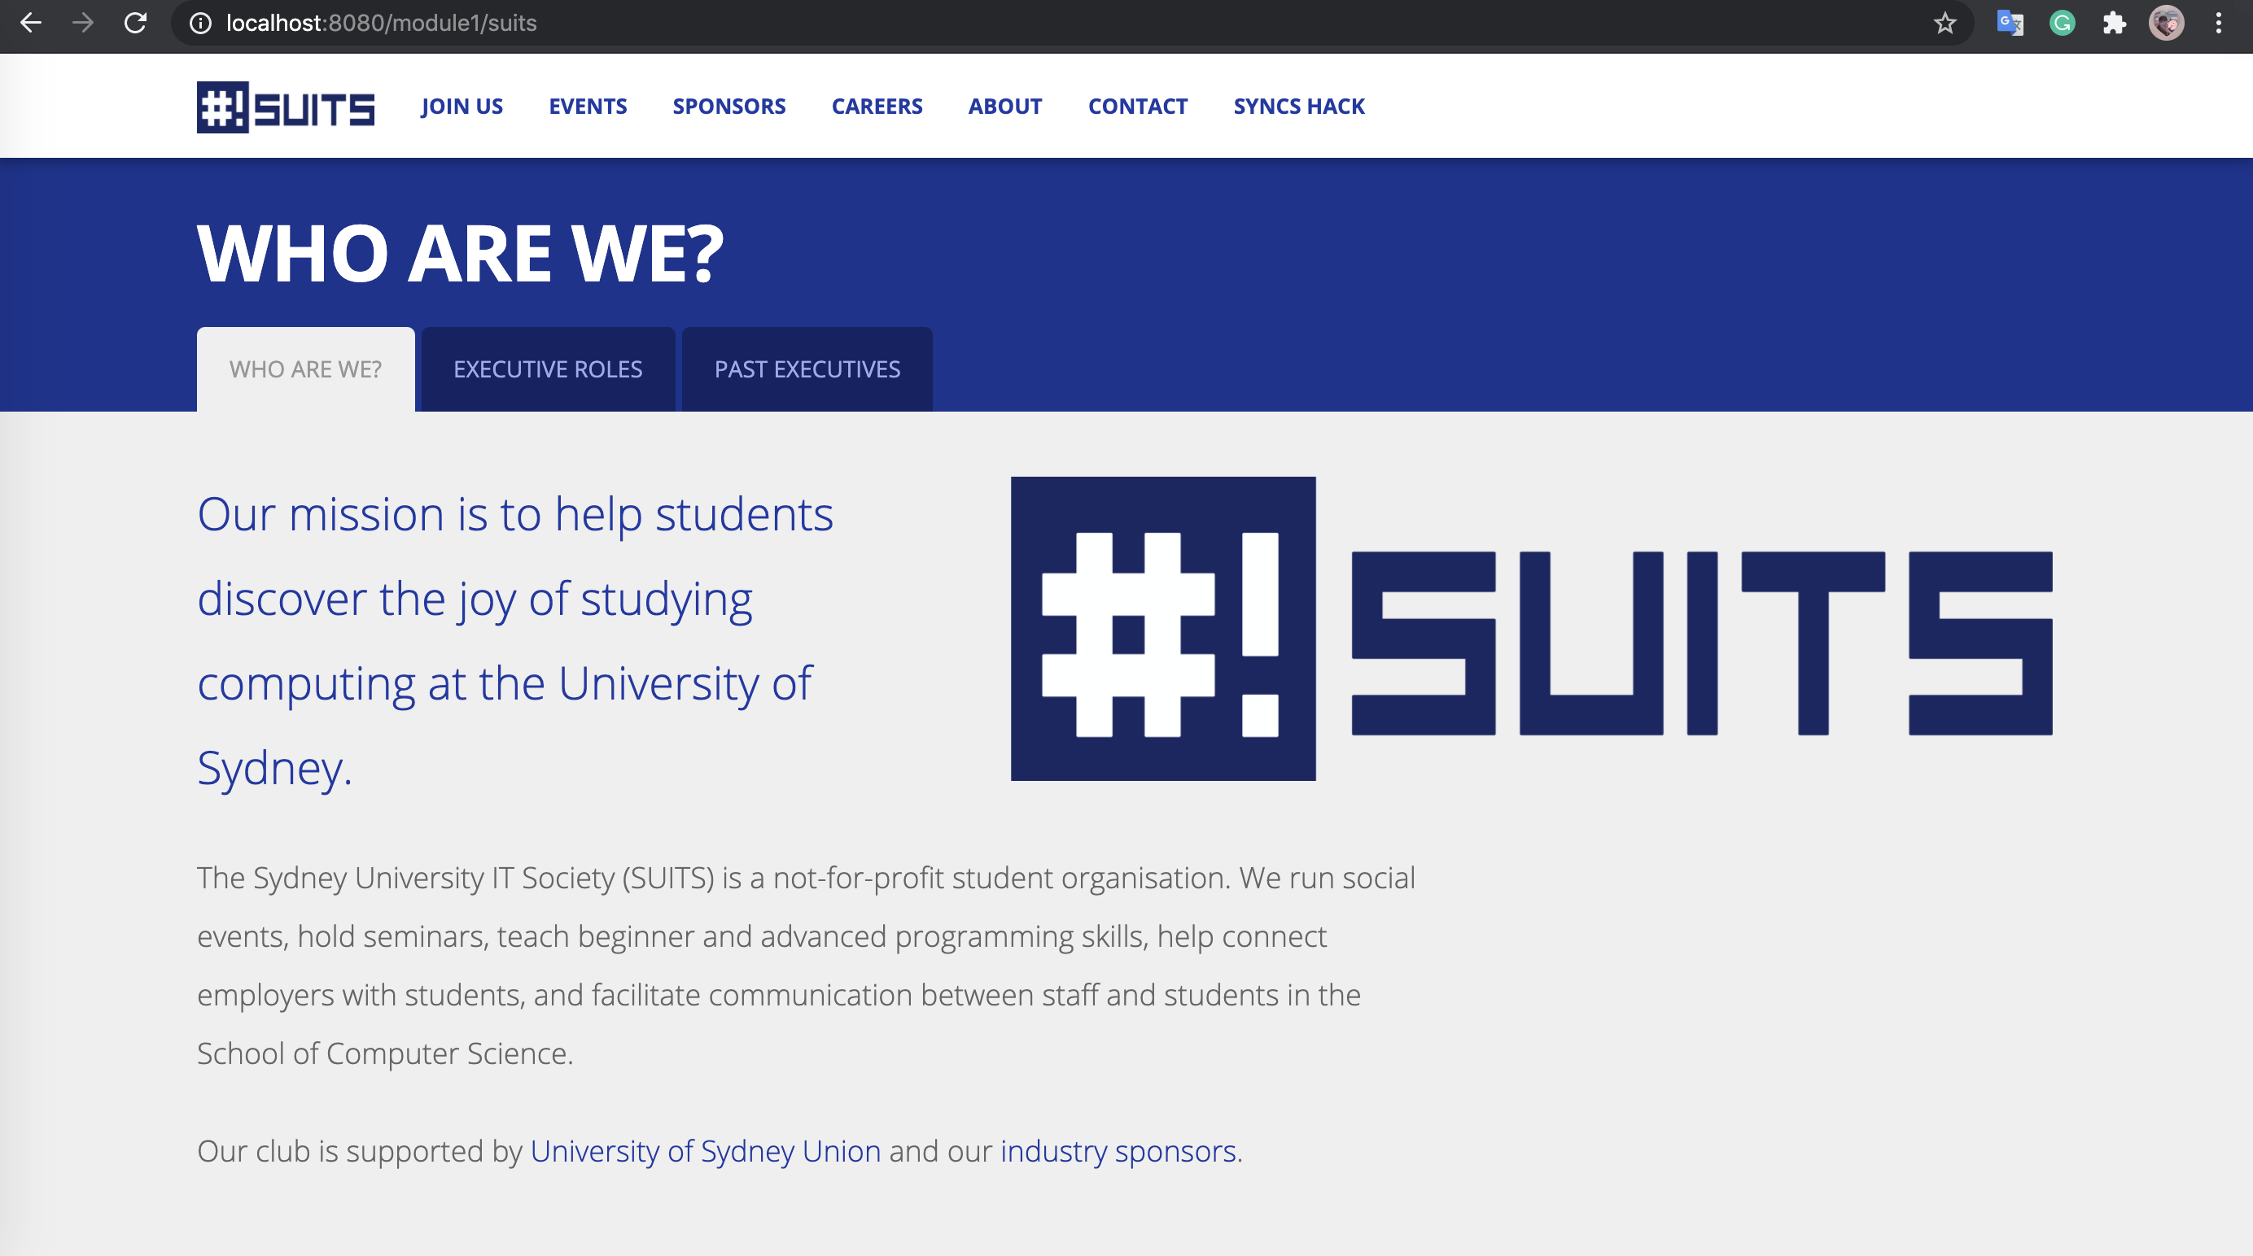

**SYNCs page accessible through routes about/suits and about/syncs**

**(You can download html code in github, if you want see code about creating)**

**Reflection:**

For this week task, I spent a lot of time on write the code about creating the ‘about us’ page and route to different pages, because I never learn something about web development before. I need pay more attention on it in order that I can improve my skills about web development. I found that persona and template are useful. They can reduce some workload and focus on the users’ needs.